Cross shelf patterns in zooplankton characteristics in a western boundary current region

Hayden T. Schilling1,2, Jason D. Everett2, Amandine Schaeffer3, Peter Yates1,2, Mark Baird4, Iain M. Suthers1,2

1Sydney Institute of Marine Science, Chowder Bay Road, Mosman, New South Wales, Australia

2Centre for Marine Science & Innovation, University of New South Wales, High Street, Kensington, New South Wales, Australia

3School of Mathematics and Statistics, University of New South Wales, High Street, Kensington, New South Wales, Australia

4Commonwealth Scientific and Industrial Research Organisation, Castray Esplanade, Battery Point, Tasmania, Australia

Corresponding author: Hayden T. Schilling ([Hayden.Schilling@sims.org.au](mailto:Hayden.Schilling@sims.org.au))

**NOTES:**

**Figures aren’t finalised. Some have minor details to fix, including interpolations**

* Figures 7 & 8 show strong patterns but they are really just repeats of Figures 3 which I think are better because they show the depth and distance from coast at the same time which I think is important. I think we should remove F7 and F8 – thoughts?
* Iain previously asked for a quantitative summary and plot of previous work (section 2.5) which looked at changes in biomass/abundance across continental shelves. I have not included this in this version because it is not finished and I’m unsure of the value of adding this information as it was already included as a table in Marcolin (2013) where they identified it may not be appropriate to compare all the studies.

Abstract

Zooplankton are the basis for many pelagic ecosystems, yet it is largely unknown how the zooplankton community varies with both depth and across continental shelves, particularly in areas influenced by strong boundary currents. Western boundary currents are known to influence continental shelf waters through a variety of physical mechanisms including uplift which have the potential to influence the planktonic community. Using an optical plankton counter with CTD on undulating towed body, here we show that in four cross shelf transects on the east Australian continental shelf, zooplankton biomass tends to be highest inshore with a decline in biomass visible with both increasing distance from shore and depth in the water column. Within uplift influenced zones, the inner shelf zooplankton communities also tended to be more productive with smaller geometric means sizes and steeper normalised biomass size spectrum slopes observed in transects influenced by the East Australian Current. This study presents the first high resolution depth resolved profiles of the zooplankton community across a continental shelf. The patterns observed in this study align with previous research on zooplankton distributions on continental shelfs suggesting that globally inner continental shelf regions appear to be more productive and support high biomasses of zooplankton compared to offshore, particularly where uplift may be a common occurrence. This may be a driver of the highly productive fisheries which are often found on continental shelfs.

1 Introduction

Western boundary currents (WBCs) are fast-flowing currents which transport warm salty water from low latitudes poleward. As they flow along continental boundaries they generally inhibit cross-shelf transport due to their strong along-shore flows (Roughan et al. 2011). At a more local scale, WBCs interact with the continental shelfs to generate eddies, fronts and upwelling often increasing transport across the continental shelf (Malan et al. 2020). By increasing uplift of cold water on the continental shelf, WBCs contribute to production through the supply of nutrients normally found in cooler deeper water (Pereira Brandini et al. 2014).

Within uplift dominated systems such as western boundary currents, zooplankton have been shown to have important keystone roles (Libralato et al. 2006). These roles include transferring energy to fish (Marquis et al. 2011; Champion et al. 2015) as well as linking the benthic and pelagic zones. It has been estimated that zooplankton support up to 53 % of fish biomass on temperate coastal reefs (Truong et al. 2017). Within coastal pelagic ecosystems, predator-prey interactions are usually driven by size (Barnes et al. 2010). By focusing on the size distribution of the zooplankton community, complex species-specific dynamics can be simplified. One method of analyzing the size structure is through the normalized biomass size spectrum, which uses simple metrics to quantify a community (Kerr and Dickie 2001). Using a linear fit of normalized biomasses in logarithmically equal size bins, the structure of the zooplankton community is quantified, with a general overall slope of -1 observed in the open sea (Baird et al. 2008). A steeper slope with large amounts of small particles generally infers higher production while a shallow slope often represents lower predation and less ‘top-down’ pressure (Moore and Suthers 2006; Blanchard et al. 2017).

Zooplankton are not distributed uniformly across continental shelves with oceanographic features a key factor in their distribution. The distribution of zooplankton is the result of a number of factors including physical mechanisms such as transport and retention, biological factors including prey availability and predator abundance as well as behavior of the zooplankton (Huntley et al. 2000). In the southeast Atlantic it was shown that the zooplankton community on the continental shelf had higher biomass and a steeper Normalised Biomass Size Spectrum (NBSS) slope compared to the offshore oceanic stations which were typically more vertically stratified (Marcolin et al. 2013). This is similar to studies in the northeast Atlantic where high zooplankton biomasses and steeper NBSS were found in some but not all inshore regions with the majority of high productivity areas located along the French coastline with productivity and biomass decreasing in offshore areas (Sourisseau and Carlotti 2006; Irigoien et al. 2009; Vandromme et al. 2014). This onshore-offshore gradient in biomass has also been observed in the southwest Atlantic where it was identified that vertical distributions of zooplankton on the continental shelf are likely related to water masses (Pereira Brandini et al. 2014). Despite exploration of spatial patterns in zooplankton, few studies have examined patterns of zooplankton with depth on continental shelfs. Off New York, during late summer it was observed that vertical zooplankton abundance was strongly influenced by water mass with distinct zooplankton communities driven by a strong thermocline (Turner and Dagg 1983). This is contrasted by a winter study on the Abrolhos Bank where on the shelf, copepod abundance peaked near the surface (20 – 40m) and decreased with depth (Marcolin et al. 2015). Recently it has been suggested that light availability and predation by fish is thought to be a significant driver of zooplankton depth distributions (Aarflot et al. 2019).

The East Australian Current (EAC) is a baroclinic jet which forms between 10 and 20 °S when the South Equatorial Current diverges against the Australian coast. It flows south at approximately 0.5 – 1 m s-1 flowing along the continental shelf (Archer et al. 2017) until the majority of the EAC separates from the coast at approximately 30 – 32 °S and continues to flow eastward as the EAC eastern extension (Cetina-Heredia et al. 2014; Oke et al. 2019). The remaining portion of the EAC continues to flow south along the coast as part of the EAC southern extension generating a large eddy field (Everett et al. 2012). Along the continental shelf, particularly in the where the continental shelf narrows, the EAC had significant impact on shelf circulation (Schaeffer et al. 2013). Current driven bottom friction leads to Ekman transport in the bottom boundary layer, moving cooler denser water up the slope, resulting in uplift of isotherms and upwelling (Schaeffer et al. 2014). These upwelling events have been shown to bring nutrient rich water into the euphotic zone, increasing primary productivity (Rossi et al. 2014) and controlling vertical phytoplankton abundance, composition and distribution (Armbrecht et al. 2014; Armbrecht et al. 2015). Phytoplankton and nutrients are a key energy source for zooplankton, and it is highly likely that the EAC is influencing zooplankton communities like the phytoplankton communities. Despite this there is little information on how western boundary currents influence depth distribution of zooplankton on continental shelves around the world and no analyses of zooplankton distribution in the EAC continental shelf region. This study therefore aims to investigate cross shelf and depth stratified patterns of zooplankton on the east Australian continental shelf.

2. Materials and Methods

*2.1 Voyage details*

From 2nd – 13th September 2004, a research cruise on the on the RV Southern Surveyor was conducted, starting from Sydney, Australia, concluding in Brisbane, Australia. During this period the EAC was flowing southward along the coast until approximately 31 °S where it separated from the mainland and continued flowing to the east. This separation resulted in the formation of a large anti-cyclonic warm-core eddy forming off the coast at approximately 33 °S, 155 °E (Figure 1).

*2.2 Sampling*

Four constant latitude transects were sampled roughly perpendicular to the north NSW coast over a seven-day period (6th – 12th September; Table 1) using a towed device called the Bunyip (a highly modified SeaSoar). The Bunyip was towed from inshore to offshore and varied between the 10 and 120 m depth, sampling temperature, salinity, and, using an optical plankton counter (OPC; Herman 1992), the size distribution of particulate matter. The ship was also equipped with an ADCP which continuous monitored the velocity of water beneath the vessel with alongshore velocity of currents calculated by rotating the U and V vectors to account for the angle of the coastline at each location. The shelf sampling was interrupted on the 8-10th September to undertake a wake study around North Solitary Island (29°55'S, 153°23'E) which will be reported elsewhere. All times reported are local (Sydney) Australian Eastern Standard Time.

*2.3 Zooplankton Data*

The zooplankton community was quantified using an Optical Plankton Counter (OPC; Herman 1992). The OPC was mounted on the Bunyip, a customised towed device. The OPC is a Focal Technologies Corporation Model OPC-2T with a sampling aperture of 2 x 10 cm. The OPC records equivalent spherical diameters (ESD) of particles that pass through the instrument in a 0.5 s interval. The particle sizes are recorded digitally into 4096 bins, corresponding within the operating range of the instrument to bins with a 5 and 15 µm width.

The volume of flow through the sample region is based on distance measured, averaged over a 6 s interval. The choice of time interval is a trade-off between a larger time period to obtain a higher particle count to accurately obtain the estimate of the size distribution, and a shorter time period to provide better spatial resolution. The spatial averaging is along the instrument trajectory. As the instrument moves vertically at approximately 1 m s-1, a long period averaging most affects vertical resolution. A 6 s interval provides the best resolution of spatial distribution of size distribution of the Tasman Sea waters with a biomass of ≈ 1-10 mmol N m-3 (REFERENCE).

To quantify the zooplankton community several metrics were calculated for each 6 s interval of our transects. These included total biomass (mg m-3), geometric mean size (µm ESD) and an estimate of the normalised biomass size spectrum (NBSS) slope. As traditional NBSS slope estimates can be biased by size bins containing zero particles, particularly when smaller volumes are filtered such as in this study, we used the Pareto distribution to estimate the NBSS slopes along the zooplankton transects. The shape parameter *c* of the Pareto distribution is highly correlated to the slope of the NBSS which makes it a more robust estimate of the NBSS slope when there are size bins containing no particles (Vidondo et al. 1997; Suthers et al. 2006). The Pareto distribution has a probability density function (pdf) defined as:

$$pdf(s)=ck^{c}s^{-(c+1)}$$

where *s* is the size of the particle (such as the weight class, *w)*, and *c* and *k* are the distribution’s shape and scale parameters, respectively (Vidondo et al. 1997). An efficient estimator of –*c* is the slope of the logarithm of the probability that a particle of random volume *W* will exceed a size *w*, log10 Prob(*W* ≥ *w*), against log10 *w*. The slope of the NBSS is an unbiased, although inefficient estimator of –*c* (Vidondo et al. 1997). As a result, within the limitations of our data, and their conformity to the Pareto distribution, the slope of the NBSS should approximately equal the slope of log10 Prob(*W* ≥ *w*) regressed against log10(*w*). The OPC records the time and size of each particle detected, allowing the Pareto distribution to be calculated without further binning of the raw digital signal that is necessary for the NBSS. In this paper we will present the Pareto shape parameter as an estimate of the NBSS slope as it has been used successfully in this region previously to spatially resolve the size distribution of particles (Baird et al. 2008). SOME OF THIS paragraph may be unnecessary but was from one of the other Baird papers and I’m not really sure about how best to explain the pareto.

*2.4 Other Environmental Data*

To investigate environment conditions leading up to the sampling of transects on the east Australian continental shelf, MODIS Level 3 ocean-colour data (chlorophyll-a) were obtained from the Integrated Marine Observing System (IMOS) Data Portal (<http://imos.aodn.org.au/imos/>) at 1 km resolution. Chlorophyll-a was derived using the OC3 algorithm. MODIS data were retrieved for 5x5 pixels (~25 km2) surrounding the western and eastern edges of each transect, for the month prior to the day of sampling. To investigate seasonal variation of the EAC in the regions of our transects, 10 years (2004 – 2013) of satellite altimeter data were obtained from the IMOS Data Portal (<http://imos.aodn.org.au/imos/>) for each of our transects. The alongshore velocity was then calculated based upon the coastline and the mean and standard deviation for each month calculated. The assumption being that faster alongshore velocity would be due to increased influence of the EAC. Bathymetry data was sourced from GEBCO (GEBCO Bathymetric Compilation Group 2019).

*2.5 A global context* **(Still to finish) – OR NOT DO?**

To place our east Australian transects in a global context and identify general trends in zooplankton communities on continental shelfs we examined previous studies which investigated spatial changes in zooplankton communities over continental shelf regions. We identified X studies which investigated changes in zooplankton communities over continental shelves and if possible from each study we extracted inshore and offshore values for biomass, abundance and the NBSS slope. From each study we extracted a maximum of one inshore-offshore per 1 latitude of sampling with the data restricted to spring/early summer to reduce seasonal influences as this is when the majority of studies were undertaken.

Specific details on quantifying needed

3 Results

*3.1 Regional Oceanography*

The three northern most sites (north of 30° S) all crossed from cool inshore waters into warm (21 °C) EAC water. This is contrasted by the southern transect (Diamond Head 31.75°S) transect which was located south of the separation zone in cooler (<19.5 °C) waters and did not cross into EAC waters. All transects showed low chlorophyll levels (<1.4 mg m-3) peaking at the surface which was representative of the previous month of low chlorophyll-a at these locations (Figure S1). There was also with negligible wind effects in the 3 days prior to the transects.

*3.2 Cape Byron (28.6°S)*

The northernmost transect at Cape Byron (28.6°S) was dominated by the EAC which had a strong southward flow (1.50 m s-1) centred over the 200 m isobath (27.6 km offshore), which resulted in most of the continental shelf being flooded by warm EAC water (Figure 2). The EAC also showed slight onshore movement which increased offshore and with depth (up to 0.26 m s-1). The strong EAC flow resulted in strong current driven uplift of the isotherms inshore of the EAC with the 21 °C isotherm rising to the surface from 70 m depth over 5 km and the 20 °C isotherm rising to the surface from 100m depth over 15 km.

Along the northern transect, a consistent decline in zooplankton biomass was observed from both inshore to offshore and from the surface to depth with the highest biomass (~750 mg m-3) observed at the surface ~20km from the coastline, just inshore of the 21°C isotherm. This 21C isotherm appears to be a strong delineator of both zooplankton biomass and the NBSS slope. The EAC waters warmer than 21°C were characterised by low zooplankton biomass with a geometric mean size of ~450µm with a NBSS Slope between -1 and -1.3. The cooler water immediately inshore of the 21°C isotherm had a high zooplankton biomass, shallower Pareto slope (-0.9) with large particles (geometric mean size 500µm). Further inshore again (15 -17 km from the coastline), in water < 20 °C, biomass remained high, but the particles were smaller (~430 µm), resulting in a steeper NBSS slope (~-1.25).

*3.3 Evans Head (29°S)*

The transect slightly further south at Evans Head (29°S) did not go as far offshore as the other transects but was still largely influenced by the EAC which had a strong southward flow (1.47 m s-1) centred further offshore at 36.1 km from the coast, near the edge of the continental shelf (220 m bathymetry; Figure 2). The EAC had a slight offshore movement (0.27 m s-1) which increased with distance offshore. There was strong current driven uplift of the isotherms inshore of the EAC with the 21 °C isotherm rising to the surface from 70m depth over 6 km and the 20 °C isotherm rising to the surface from 100m depth over 15 km.

The zooplankton community was strongly related to the water masses along the transect with strong relationships observed with temperature. Around the front between the continental shelf water (<21°C) and the warm (> 21°C) EAC water the zooplankton community showed a similar geometric mean size of ~450µm to that observed at the northern Cape Byron transect but had a higher biomass and shallower NBSS Slope (~-1; Figures 3, 4 & 5). In the cool inshore waters <20°C, there continued to be high zooplankton biomass, but the community had shifted towards smaller particles which resulted in a steep NBSS slope (< -1.3; Figure 5).

*3.4 North Solitary (30°S)*

The transect at North Solitary (30°S) showed the strongest evidence of current driven uplift of any of the transects with the 21 °C isotherm rising to the surface from 70m depth over 3 km and the 20 °C isotherm rising to the surface from 100m depth over 10 km (Figure 3). The offshore portion of the transect continued to be dominated by the EAC which had a strong southward flow (1.59 m s-1) centred 37.7 km offshore (310 m bathymetry) with the EAC having slight onshore movement, offshore and at depth (0.15 m s-1; Figure 2).

The biomass of the zooplankton community generally decreased with distance offshore and with depth. The EAC, particularly further offshore was low in biomass with a shallow NBSS slope (-0.9) and geometric mean size of ~450µm. The 20°C isotherm was a strong boundary for zooplankton communities with zooplankton in water < 20°C having relatively low biomass and a much smaller geometric mean size (~400µm) resulting in a steeper NBSS slope (< -1.3). This was particularly evident where the 20°C isotherm reach the surface ~24 km from the coastline (Figures 4 & 5).

*3.5 Diamond Head (31.75°S)*

The most southern transect located at Diamond Head (31.75°S) was not influenced by the EAC which had separated from the coast to the north and as such was characterised by a more homogeneous water mass. Within the transect the, alongshore velocities are low (< 0.43 m s-1) with low onshore movement of water (0.11 m s-1) in the surface waters and offshore movement (0.27 m s-1) in the deeper waters (Figure 2). There was minor uplift of the temperature isotherms with all isotherms rising approximately 20 – 40 m as they came onto the continental shelf. This uplift is likely caused by the separation of the EAC from the coast to the north, generating uplift through the creation of eddies near Diamond Head rather than current driven uplift observed at the northern EAC influenced sites (Roughan and Middleton 2002).

Reflecting the more homogenous water mass along this transect, the zooplankton community was not related to water masses and changes can be more attributed to physical location. Inshore, the zooplankton community was larger (~500µm) and had higher overall biomass which declined steadily with distance offshore and with depth (Figures 3 & 4). The NBSS slope of the community was shallow and steady over the whole transect (~-0.9; Figure 5).

*3.6 Overall Patterns and Seasonal Changes in the EAC*

Satellite altimetry showed throughout the year alongshore velocity varies at all of our transects by approximately 0.25m s-1 with the more northern sites having the fastest overall flow (Figure 6). The velocity at all sites slows between April and August before peaking in peaking during September or October and remaining high until March.

Both EAC influenced transects and transects south of the EAC showed that the highest zooplankton biomasses were observed in the inner shelf waters with general declines offshore and with depth (Figures 7 & 8). The Evans Head and North Solitary transects also showed elevated biomass levels (~700 mg m-3)at the outer edge of the continental shelf around the 21 °C isotherm at a front between the EAC and continental shelf water. The transect at Evans Head did not show a noticeable decline in biomass with distance from the coast but this transect did not extend past the edge of the continental shelf where the declines were seen in the other 3 transects.

Two distinct patterns in Geometric mean size (GMS) were evident in our 4 transects. Cape Byron and Diamond Head had a larger GMS towards the coast (> 475 µm ESD) with the GMS declining offshore. Evans Head and North Solitary showed a small increase in GMS around the 21 °C isobar which formed a front between the EAC and coastal waters. All sites also showed a general decline in GMS with depth. Patterns in GMS were also reflected in the NBSS slope with steeper slopes generally observed in areas with a smaller GMS.

4. Discussion

Declines in biomass with distance from the coast and with depth, combined with different community structure across the continental shelf shown by the normalised biomass size spectrum slope highlight the importance of recognising the continental shelf region as an oceanographic region with different biological processes compared the open ocean. Distinct from the fast flowing EAC water mass, in the cooler inner shelf water we observed a zooplankton community with higher biomass, smaller geometric mean size and steeper normalised biomass size spectrum slope compared to the offshore community. These features together suggest higher productivity and increased predation on the continental shelf compared to the communities in the open ocean. This increased productivity driven by the uplift of the cooler water is likely an important driver for fisheries on the continental shelf region.

*4.1 Effects of the EAC on Zooplankton*

While current driven uplift explains the higher productivity and therefore biomass found in the three northern sites which were influenced by the EAC as it pushed cooler nutrient rich water onto the continental shelf (Roughan and Middleton 2002), the pattern of increased biomass on the continental shelf was also observed on at the most southern site (Diamond Head; 31.75° S) which was most likely influenced by uplift generated by the separation of the EAC to the north (Roughan and Middleton 2002). This southern transect was dominated by the Tasman Sea with larger particles and shallower NBSS slope compared to the EAC influenced northern sites. The Tasman sea is known to have higher nutrient content and generally hold higher amounts of zooplankton compared to the oligotrophic EAC waters (Baird et al. 2008), explaining the high biomass overall but the cause of the declining gradient with distance offshore is uncertain, it is possible that the zooplankton are being retained on the continental shelf due to weak flow in the lee of the EAC separation (Everett et al. 2014) or it is possible that there are more nutrients closer to shore due to anthropogenic inputs. The larger geometric mean size and a shallower NBSS slope suggest that the Tasman Sea dominated southern site potentially has low predation relative to the other transects as the biomass was the highest observed of all transects.

Seasonally the influence of the EAC as an uplift mechanism will vary. Over a year, the EAC pushes southward and strengthens (Ridgway and Godfrey 1997). This will influence the various locations of the transects in this study differently. The most northern site (Cape Byron 28°S) is also the most exposed, located off a headland pushing directly out into the EAC. This results in the EAC regularly flooding the continental shelf in this region, removing any continental shelf water that may have been retained. Further south where the coastline is more angled, the EAC does not flood the continental shelf but the seasonal strengthening of the flow is likely to drive changes in the strength of uplift generated with the location where the EAC separates from the coast having a strong impact towards the south of our study region with separation driven upwelling and retention on the wider continental shelf identified as a key mechanism for productivity in this region (Suthers et al. 2011; Everett et al. 2014).

*4.2 Comparison to other studies*

All sites in this study showed there was a decline in biomass with both increasing distance from shore and depth with the largest biomasses observed in the upper inner shelf waters. This aligns with results from continental shelf locations in the southeast Atlantic, northeast Atlantic and southwest Atlantic which all showed have higher biomasses inshore compared to the offshore locations. While the northeast Atlantic pattern was attributed variable hydrology and topography, particularly over the shelf break (Sourisseau and Carlotti 2006; Irigoien et al. 2009; Vandromme et al. 2014), in the southeast Atlantic, in the Brazilian Bight, this increase in inshore plankton concentrations was attributed to bottom intrusions of cooler nutrient rich South Atlantic Central Water (Pereira Brandini et al. 2014). Slightly to the south, similar results were observed on the Abrolhos Bank with larger zooplankton biomasses observed on the continental shelf, attributed to the Brazilian Current interacting with the topography, generating uplift and eddies which increased mixing over the continental shelf (Marcolin et al. 2013). This is like the EAC interacting with the topography in the current study generating current driven uplift of cooler water onto the continental shelf. This consistent observation of high zooplankton biomass and steeper NBSS slopes inshore on continental shelves globally highlights the broad importance of the continental shelf regions for productivity as these higher zooplankton biomasses likely form part of the important pelagic food webs which have been shown to support both reef ecosystems and the larger pelagic ecosystems often targeted by the fishing industry.

Steeper NBSS slopes in inshore regions is another feature of zooplankton communities which has been previously noted. In the Bay of Biscay, the steeper NBSS slope in inshore regions is a regular occurrence, particularly on the French continental shelf (Sourisseau and Carlotti 2006; Vandromme et al. 2014). The areas of steepest slopes have been linked to estuarine influences resulting in regions of increased nutrients which are exploited by planktonic communities in this region while the steep slopes slighter further offshore are observed to be more temporally consistent and potentially due to local circulation patterns and retention (Vandromme et al. 2014). In the south-east Atlantic, continental shelf sites have been characterised by steeper, more productive NBSS slopes compared to oceanic slopes attributed to mixing on the continental shelf generated by the interaction between the topography of the Abrolhos Bank, the Brazilian Current and bottom intrusions (upwelling) of nutrient-rich South Atlantic Central Water resulting in increased benthopelagic coupling on the continental shelf and different energy sources and food availability for lower trophic levels between communities (Marcolin et al. 2013).

While none of the previous sites have examined continental shelf zooplankton communities by depth in the same detail as across the continental shelves, a number have made similar observations to that observed in the current study. In the south-east Atlantic, a higher biomass of plankton was found above the pycnocline attributed to the increased chlorophyll in these waters (Marcolin et al. 2013). In the northwest Atlantic, a similar strong association was found with a thermocline, with distinct zooplankton communities across the continental shelf separated by the 15°C thermocline (Turner and Dagg 1983). Focusing above the thermocline, abundance generally peaked at 20 – 30 m depth, which aligns with the current study.

If the current study is viewed in conjunction with previous studies of zooplankton communities across continental shelves, a consistent broad pattern emerges (Figure 9). In regions where there is interaction of currents or other upwelling promoting mechanisms, there is higher zooplankton biomass inshore compared to off the continental shelf. This higher inshore biomass is driven by larger numbers of smaller zooplankton. Combining the higher biomass and smaller geometric mean sizes of particles in the inshore region there is a gradient from steeper NBSS slopes to shallower slopes with distance offshore. Within this cross-continental pattern of zooplankton, biomass and mean size also tend to decline with depth.

*4.3 Implication for the future* **(DO I NEED THIS SECTION?)**

Globally many boundary currents are strengthening. In eastern Australia, climate change is driving substantial change in the EAC region with the flow strengthening by up to 35 % (Sun et al. 2012), and separation occurring further south (Cetina-Heredia et al. 2014). The faster flowing EAC may result in increased uplift of cooler nutrient rich water onto the continental shelf via current driven uplift (Roughan and Middleton 2002). With the EAC pushing further south before it separates from the coast, it may generate increased uplift in regions which currently have low levels of current driven uplift. On the other hand, the increasing water temperatures in the southeast Australian region are already impacting the zooplankton communities as the region becomes increasingly tropicalised, forcing some species to shift southward as they reach thermal limits or change their reproductive patterns (Kelly et al. 2016). These changes may have significant effects on the overall distribution of zooplankton biomass, size structure and community composition on continental shelves as zooplankton are impacted across the globe in similar ways (Richardson 2008).

*4.4 Limitations*

This study was based upon a single voyage which completed targeted cross-shelf transects to investigate the zooplankton communities in upwelling favourable regions. This means that the distributions observed in these transects represent a snapshot and it is possible that at other times of the year the patterns seen may vary from what we observed. Our analysis of seasonal influence by the EAC showed that while we sampled during the peak season of EAC flow, the alongshore velocities observed in our study are reflective of a large portion of the year. Despite this, our observed inshore-offshore gradient in zooplankton biomass and NBSS slopes did match those seen in other continental shelf regions around the world which supports the idea that the patterns we observed are representative of larger temporal and spatial scales. While our study is the first to look at high resolution depth patterns of zooplankton across a continental shelf, due to limitations of the Bunyip, it did not sample in areas where the bathymetry was less than 50 m. This means that the true inshore water masses which may be heavily influenced by waves and interactions with the shore were not sampled and these areas may have differing patterns in terms of the zooplankton community.

5 Conclusions

This study provides the insights in to both the depth and spatial patterns of zooplankton communities across a continental shelf. By comparing zooplankton communities in the EAC influenced region with the more southern region which is not influenced by the EAC we showed how current driven uplift creates a highly productive inner-shelf water zooplankton community. It is likely that this is reflective of other western boundary current systems where similar horizontal patterns of zooplankton biomass have been observed. Based upon the previous research into zooplankton distributions on continental shelfs and the current study we would like to propose a general model for the distribution of zooplankton on continental shelves influenced by boundary currents. This model includes a number of hypotheses for future studies to test. 1) Zooplankton biomass declines with distance offshore and with depth. 2) Continental shelf waters are more productive that offshore waters, and 3) Western boundary currents drive productivity on the shelf through mixing and uplift. Future studies could answer these questions with more sustained monitoring of cross-shelf patterns throughout the year which has not previously occurred with all previous studies presenting only snapshots of cross-shelf patterns due to defined sampling seasons or irregular research voyages.

**References**

Aarflot JM, Aksnes DL, Opdal AF, Skjoldal HR, Fiksen O (2019) Caught in broad daylight: Topographic constraints of zooplankton depth distributions. Limnology and Oceanography 64: 849-859

Archer MR, Roughan M, Keating SR, Schaeffer A (2017) On the Variability of the East Australian Current: Jet Structure, Meandering, and Influence on Shelf Circulation122: 8464-8481

Armbrecht LH, Roughan M, Rossi V, Schaeffer A, Davies PL, Waite AM, Armand LK (2014) Phytoplankton composition under contrasting oceanographic conditions: Upwelling and downwelling (Eastern Australia). Continental Shelf Research 75: 54-67

Armbrecht LH, Thompson PA, Wright SW, Schaeffer A, Roughan M, Henderiks J, Armand LK (2015) Comparison of the cross-shelf phytoplankton distribution of two oceanographically distinct regions off Australia. J Mar Syst 148: 26-38

Baird ME, Timko PG, Middleton JH, Mullaney TJ, Cox DR, Suthers IM (2008) Biological properties across the Tasman Front off southeast Australia. Deep-Sea Res Part I-Oceanogr Res Pap 55: 1438-1455

Barnes C, Maxwell D, Reuman DC, Jennings S (2010) Global patterns in predator–prey size relationships reveal size dependency of trophic transfer efficiency. Ecology 91: 222-232

Blanchard JL, Heneghan RF, Everett JD, Trebilco R, Richardson AJ (2017) From Bacteria to Whales: Using Functional Size Spectra to Model Marine Ecosystems. Trends Ecol Evol 32: 174-186

Cetina-Heredia P, Roughan M, van Sebille E, Coleman MA (2014) Long-term trends in the East Australian Current separation latitude and eddy driven transport. Journal of Geophysical Research: Oceans 119: 4351-4366

Champion C, Suthers IM, Smith JA (2015) Zooplanktivory is a key process for fish production on a coastal artificial reef. Marine Ecology Progress Series 541: 1-14

Everett JD, Baird ME, Oke PR, Suthers IM (2012) An avenue of eddies: Quantifying the biophysical properties of mesoscale eddies in the Tasman Sea. Geophys Res Lett 39: 5

Everett JD, Baird ME, Roughan M, Suthers IM, Doblin MA (2014) Relative impact of seasonal and oceanographic drivers on surface chlorophyll a along a Western Boundary Current. Progress in Oceanography 120: 340-351

GEBCO Bathymetric Compilation Group (2019) The GEBCO_2019 Grid - a continuous terrain model of the global oceans and land. In: British Oceanographic Data Centre NOC, NERC, UK (ed) 10/c33m

Herman AW (1992) Design and calibration of a new optical plankton counter capable of sizing small zooplankton. Deep Sea Research Part A Oceanographic Research Papers 39: 395-415

Huntley ME, GonzÃÂ¡lez A, Zhu Y, Zhou M, Irigoien X (2000) Zooplankton dynamics in a mesoscale eddy-jet system off California. Marine Ecology Progress Series 201: 165-178

Irigoien X, Fernandes JA, Grosjean P, Denis K, Albaina A, Santos M (2009) Spring zooplankton distribution in the Bay of Biscay from 1998 to 2006 in relation with anchovy recruitment. Journal of Plankton Research 31: 1-17

Kelly P, Clementson L, Davies C, Corney S, Swadling K (2016) Zooplankton responses to increasing sea surface temperatures in the southeastern Australia global marine hotspot. Estuarine, Coastal and Shelf Science 180: 242-257

Kerr SR, Dickie LM (2001) The biomass spectrum: a predator-prey theory of aquatic production. Columbia University Press

Libralato S, Christensen V, Pauly D (2006) A method for identifying keystone species in food web models. Ecological Modelling 195: 153-171

Malan N, Archer M, Roughan M, Cetina-Heredia P, Hemming M, Rocha C, Schaeffer A, Suthers I, Queiroz E (2020) Eddy-Driven Cross-Shelf Transport in the East Australian Current Separation Zone. Journal of Geophysical Research: Oceans 125: e2019JC015613

Marcolin C, Lopes R, Jackson G (2015) Estimating zooplankton vertical distribution from combined LOPC and ZooScan observations on the Brazilian Coast. Mar Biol 162: 2171-2186

Marcolin CdR, Schultes S, Jackson GA, Lopes RM (2013) Plankton and seston size spectra estimated by the LOPC and ZooScan in the Abrolhos Bank ecosystem (SE Atlantic). Continental Shelf Research 70: 74-87

Marquis E, Niquil N, Vézina AF, Petitgas P, Dupuy C (2011) Influence of planktonic foodweb structure on a system's capacity to support pelagic production: an inverse analysis approach. ICES J Mar Sci 68: 803-812

Moore SK, Suthers IM (2006) Evaluation and correction of subresolved particles by the optical plankton counter in three Australian estuaries with pristine to highly modified catchments. Journal of Geophysical Research: Oceans 111

Oke PR, Roughan M, Cetina-Heredia P, Pilo GS, Ridgway KR, Rykova T, Archer MR, Coleman RC, Kerry CG, Rocha C, Schaeffer A, Vitarelli E (2019) Revisiting the circulation of the East Australian Current: Its path, separation, and eddy field. Prog Oceanogr 176: 102139

Pereira Brandini F, Nogueira M, Simião M, Carlos Ugaz Codina J, Almeida Noernberg M (2014) Deep chlorophyll maximum and plankton community response to oceanic bottom intrusions on the continental shelf in the South Brazilian Bight. Continental Shelf Research 89: 61-75

Richardson AJ (2008) In hot water: zooplankton and climate change. ICES J Mar Sci 65: 279-295

Ridgway KR, Godfrey JS (1997) Seasonal cycle of the East Australian Current. Journal of Geophysical Research: Oceans 102: 22921-22936

Rossi V, Schaeffer A, Wood J, Galibert G, Morris B, Sudre J, Roughan M, Waite AM (2014) Seasonality of sporadic physical processes driving temperature and nutrient high-frequency variability in the coastal ocean off southeast Australia. Journal of Geophysical Research: Oceans 119: 445-460

Roughan M, Macdonald HS, Baird ME, Glasby TM (2011) Modelling coastal connectivity in a Western Boundary Current: Seasonal and inter-annual variability. Deep-Sea Res Part II-Top Stud Oceanogr 58: 628-644

Roughan M, Middleton JH (2002) A comparison of observed upwelling mechanisms off the east coast of Australia. Continental Shelf Research 22: 2551-2572

Schaeffer A, Roughan M, Morris BD (2013) Cross-shelf dynamics in a western boundary current regime: Implications for upwelling. J Phys Oceanogr 44: 2812-2813

Schaeffer A, Roughan M, Wood JE (2014) Observed bottom boundary layer transport and uplift on the continental shelf adjacent to a western boundary current. J Geophys Res-Oceans 119: 4922-4939

Sourisseau M, Carlotti F (2006) Spatial distribution of zooplankton size spectra on the French continental shelf of the Bay of Biscay during spring 2000 and 2001. Journal of Geophysical Research: Oceans 111

Sun C, Feng M, Matear RJ, Chamberlain MA, Craig P, Ridgway KR, Schiller A (2012) Marine Downscaling of a Future Climate Scenario for Australian Boundary Currents. J Clim 25: 2947-2962

Suthers IM, Everett JD, Roughan M, Young JW, Oke PR, Condie SA, Hartog JR, Hobday AJ, Thompson PA, Ridgway K, Baird ME, Hassler CS, Brassington GB, Byrne M, Holbrook NJ, Malcolm HA (2011) The strengthening East Australian Current, its eddies and biological effects - an introduction and overview. Deep-Sea Res Part II-Top Stud Oceanogr 58: 538-546

Suthers IM, Taggart CT, Rissik D, Baird ME (2006) Day and night ichthyoplankton assemblages and zooplankton biomass size spectrum in a deep ocean island wake. Marine Ecology Progress Series 322: 225-238

Truong L, Suthers IM, Cruz DO, Smith JA (2017) Plankton supports the majority of fish biomass on temperate rocky reefs. Mar Biol 164: 12

Turner JT, Dagg MJ (1983) Vertical Distributions of Continental Shelf Zooplankton in Stratified and Isothermal Waters. Biological Oceanography 3: 1-40

Vandromme P, Nogueira E, Huret M, Lopez-Urrutia Á, González GG-N, Sourisseau M, Petitgas P (2014) Springtime zooplankton size structure over the continental shelf of the Bay of Biscay. Ocean Science 10: 821-835

Vidondo B, Prairie YT, Blanco JM, Duarte CM (1997) Some aspects of the analysis of size spectra in aquatic ecology. Limnology and Oceanography 42: 184-192

Tables

Table 1 Summary of the four transects undertaken using the Bunyip with attached optical plankton counter and CTD.

|  |  |  |  |  |  |  |
| --- | --- | --- | --- | --- | --- | --- |
| **Transect** | **Start Longitude**  **(° E)** | **Start Latitude**  **(° S)** | **End Longitude**  **(° E)** | **End Latitude**  **(° S)** | **Start Time (Local)** | **End Time (Local)** |
| Cape Byron | 153.7039 | 28.6328 | 153.9808 | 28.6332 | 12/09/2004 8:11 | 12/09/2004 9:59 |
| Evans Head | 153.6110 | 28.9973 | 153.8583 | 29.0024 | 11/09/2004 10:55 | 11/09/2004 12:36 |
| North Solitary | 153.4115 | 29.9978 | 153.7255 | 29.9972 | 7/09/2004 21:41 | 8/09/2004 0:05 |
| Diamond Head | 152.9126 | 31.7521 | 153.1905 | 31.7470 | 6/09/2004 20:00 | 6/09/2004 21:53 |

**Figures**

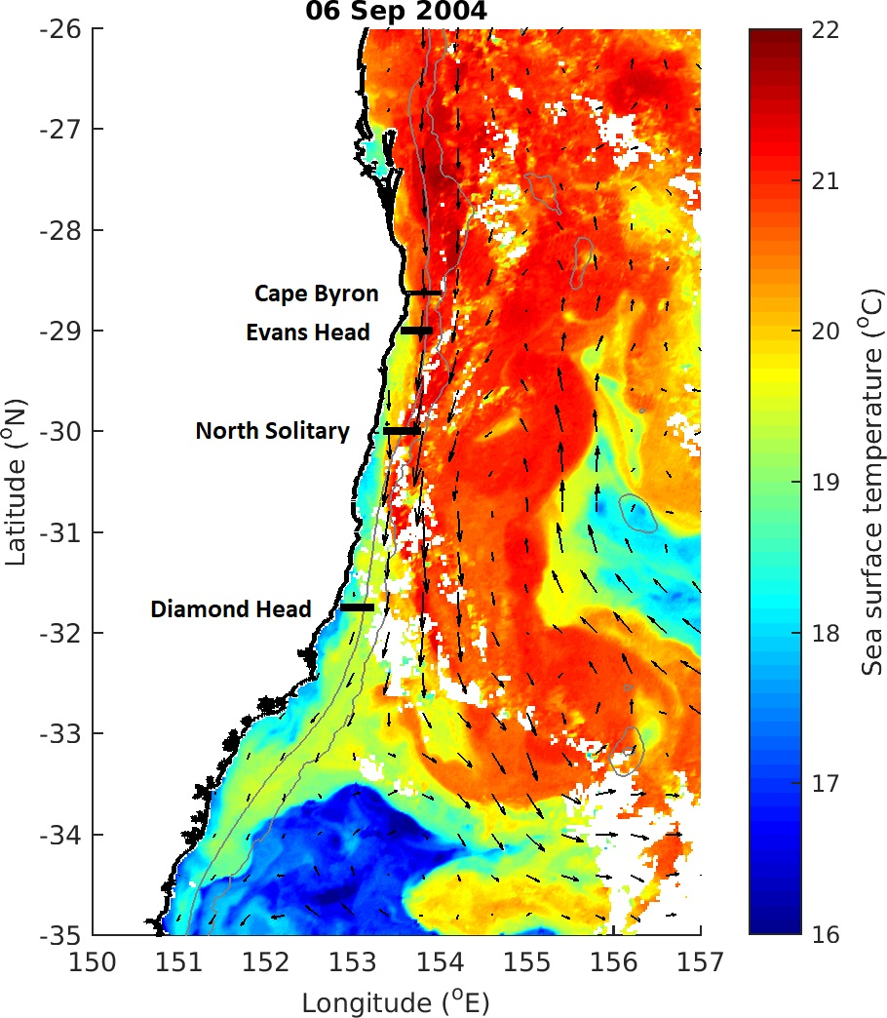

Figure 1 Locations of the four cross shelf sections which were sampled in September 2004. The sea-surface temperature for 6th September 2004 is shown in colour with velocity arrows from satellite altimetry shown with black arrows. ISOBATHS? 200 and 1000m?

Figure 2 Alongshore velocity interpolated across the four cross shelf transects (Figure 1). Transects were conducted with an Acoustic Doppler Current Profiler during a CTD Transect. Grey lines join areas of equal velocity. NEED TO Fix the interpolation issues and redo to match other plots.

**Figure 3** Zooplankton biomass (mg m-3) distributions from the four cross shelf transects (Figure 1). Transe**c**ts were conducted form inshore to offshore with an undulating towed body with the path shown by the grey line with midpoints of each sample shown as dots. Temperature (°C) isotherms are shown in black. Note the log transformed colour scale.

**Figure 4** Geometric Mean Size (µm equivalent spherical diameter) of zooplankton from the four cross shelf transects (Figure 1). Transects were conducted form inshore to offshore with an undulating towed body with the path shown by the grey line with midpoints of each sample shown as dots. Temperature (° C) isotherms are shown in black. Note the log transformed colour scale.

**Figure 5** Interpolations of the Normalised Biomass Size Spectrum slope, estimated using the Pareto method from the four cross shelf transects (Figure 1). Transects were conducted form inshore to offshore with an undulating towed body with the path shown by the grey line with midpoints of each sample shown as dots. Temperature (° C) isotherms are shown in black. Note the log transformed colour scale.

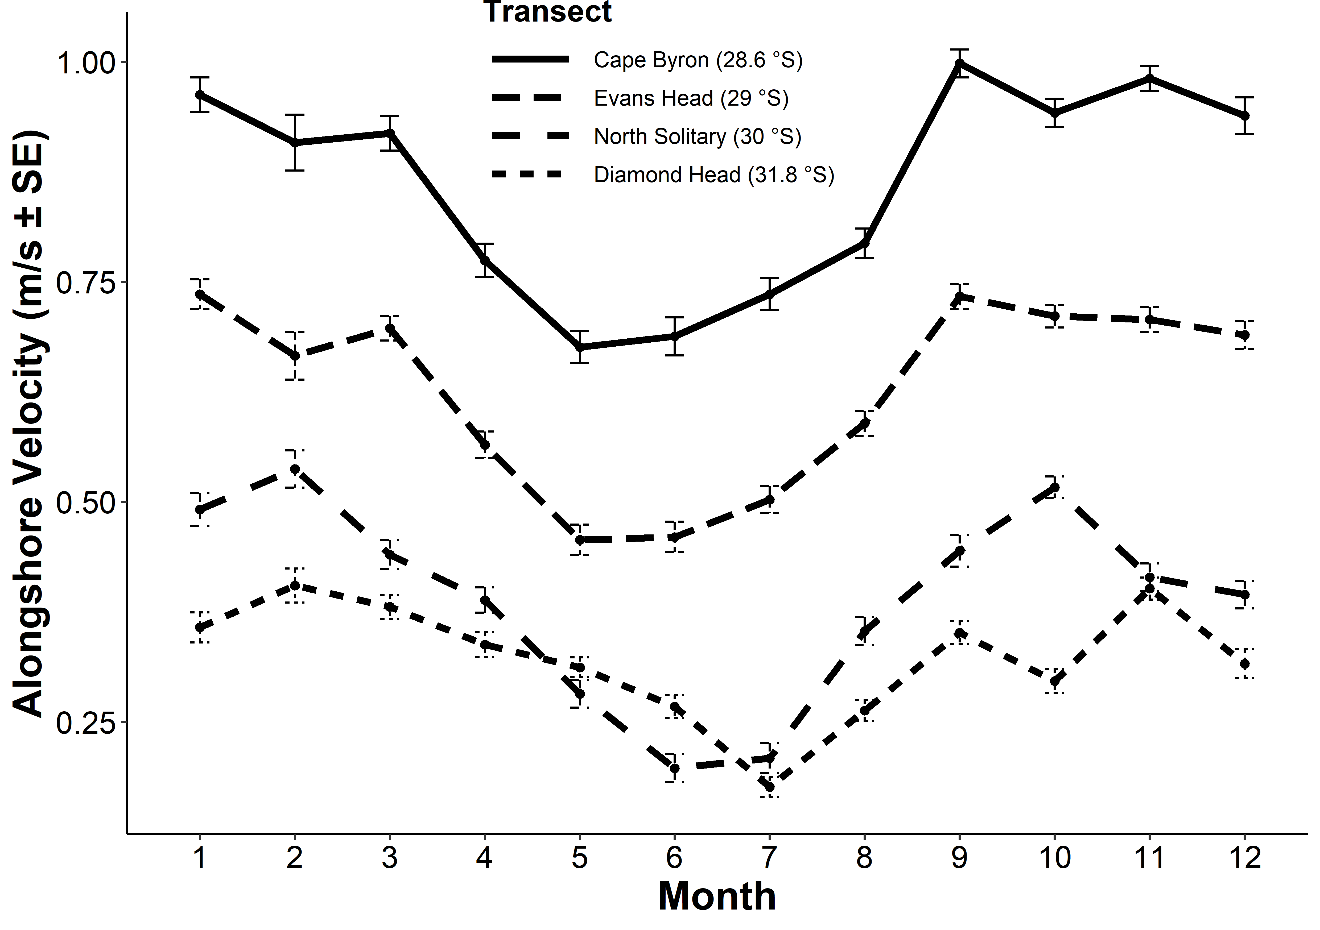

**Figure 6** Seasonal changes in alongshore velocity at our the four transects based upon satellite altimetry.

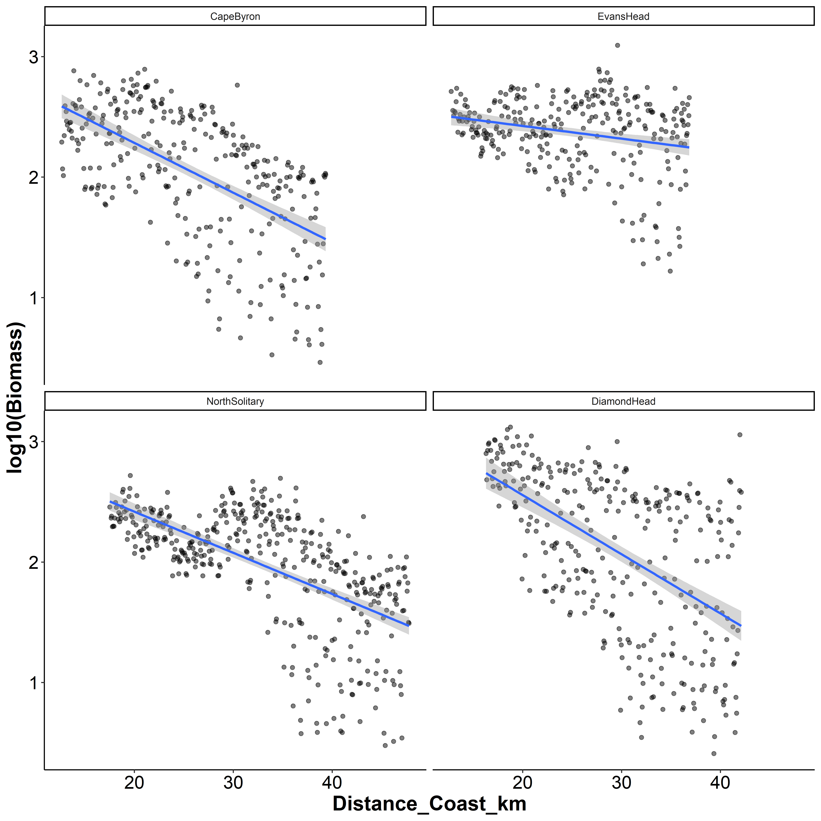

**Figure 7** Log10(Biomass) by distance from the coast for the four transects. Each dot represents a 6 s integration from the OPC mounted on the undulating towed body.

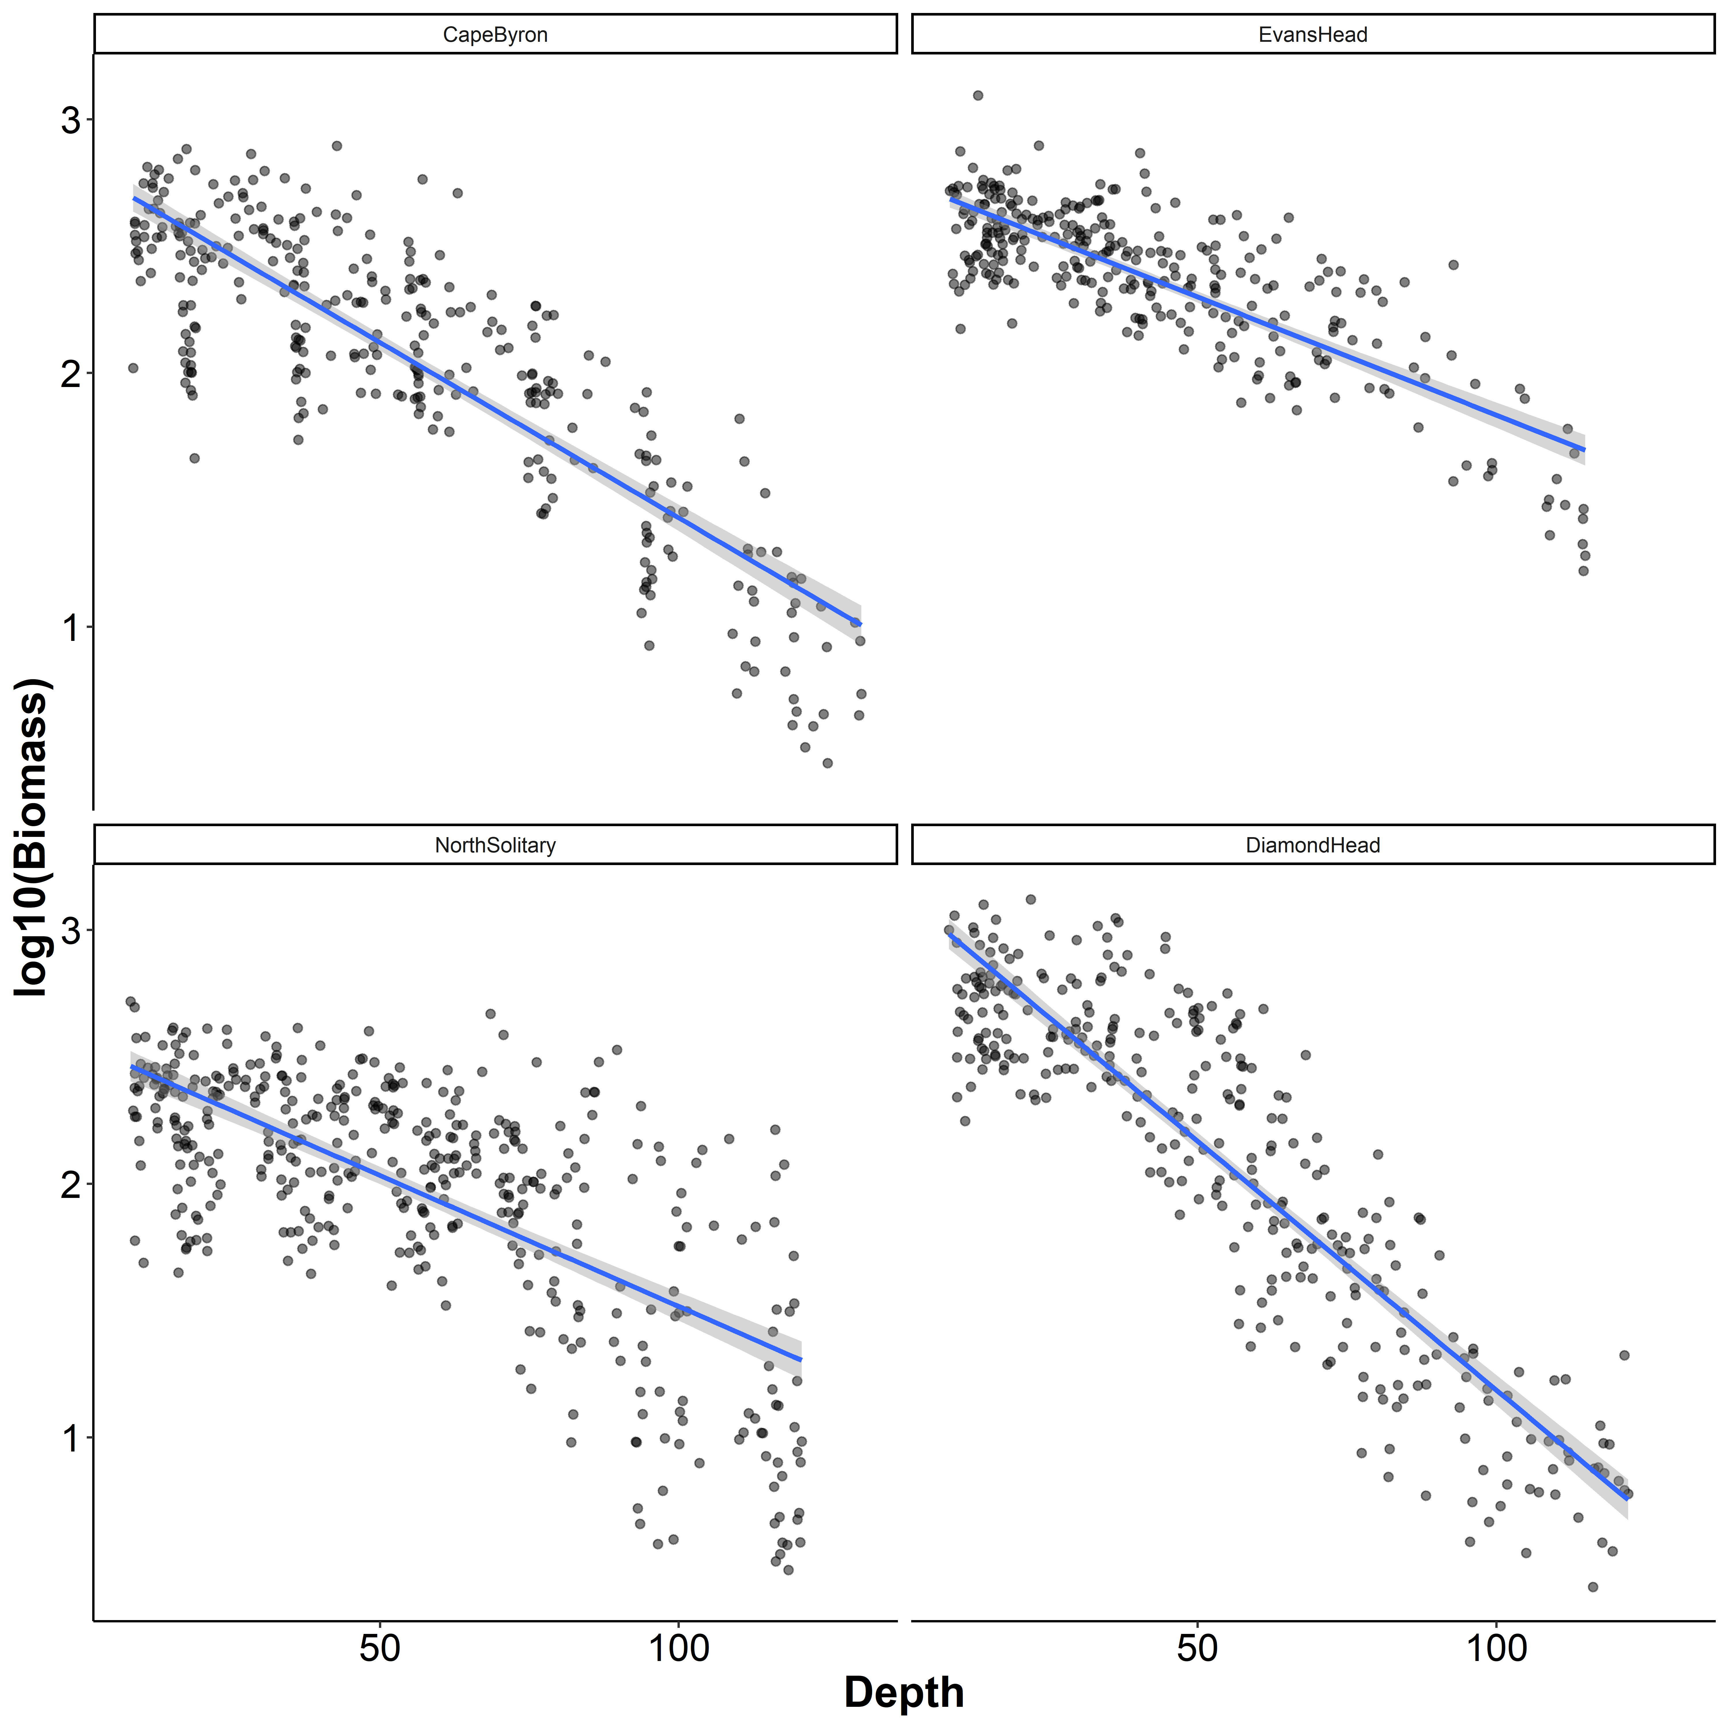

**Figure 8** Log10(Biomass) by sample depth for the four transects. Each dot represents a 6 s integration from the OPC mounted on the undulating towed body.

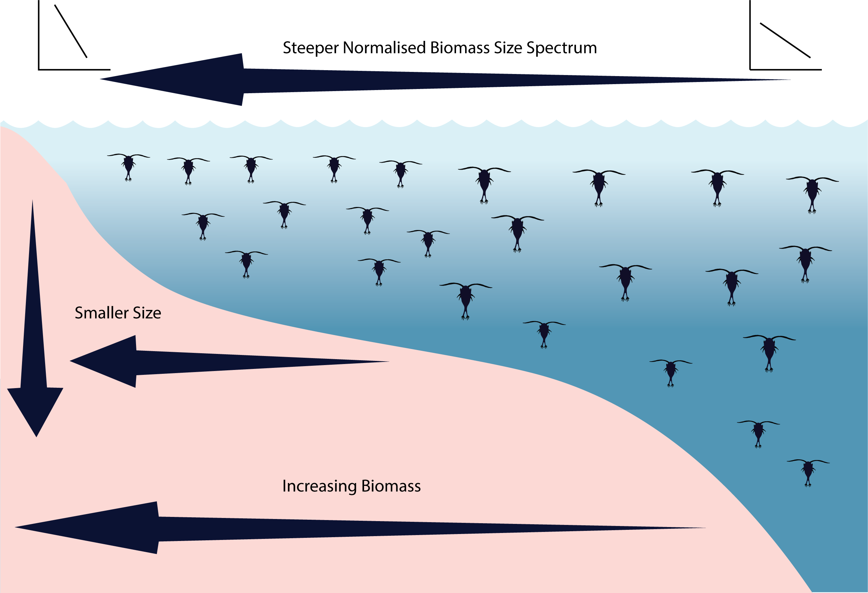

**Figure 9** Idealised concept diagram of the zooplankton community and how it changes over a continental shelf and with depth. Note all zooplankton are represented by copepods in this image.

**Supplementary Material**

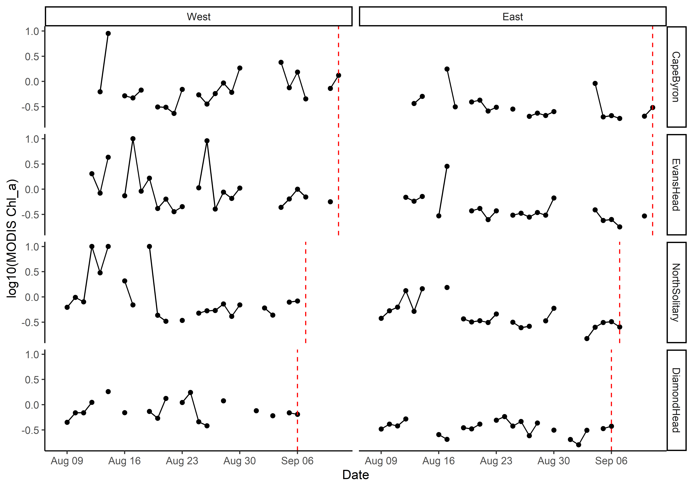

Figure S1. Satellite observed chlorophyll *a* in the month prior to each transect based upon a 5 x 5 km region around the western and eastern edges of each transect. Gaps are due to days with no data due to cloud cover. The vertical red line shows the day each transect was sampled.

To do – Tidy up plot labels etc.

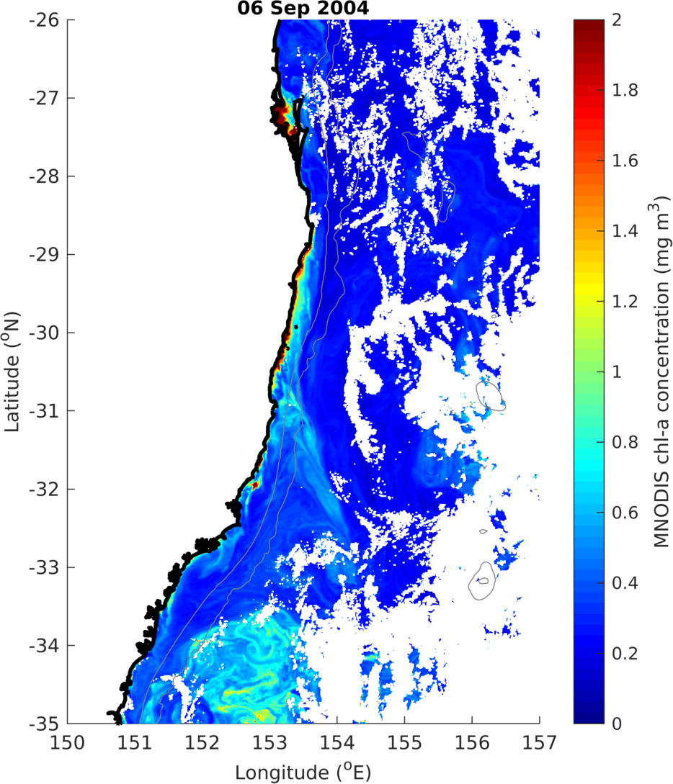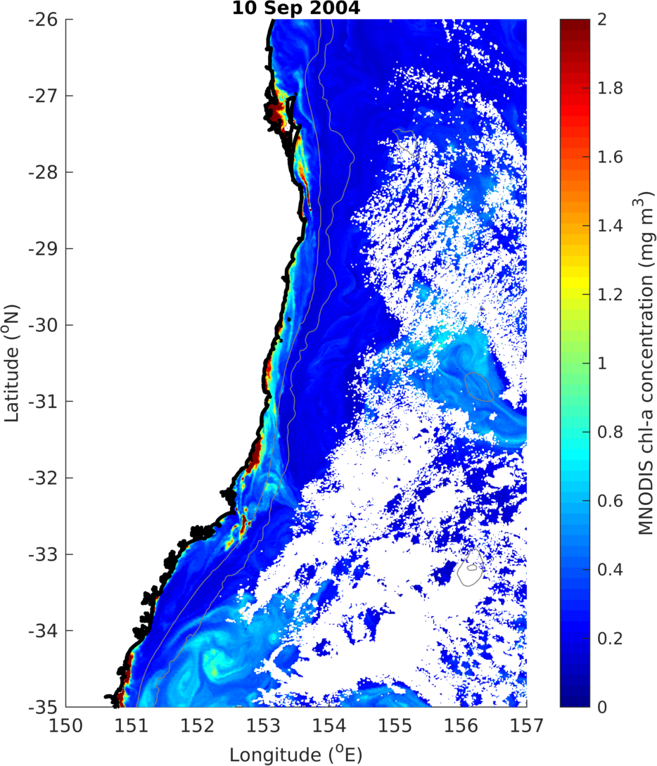

Figure S2 MODIS Chlorophyll *a* in the study region on the 6th and 10th of September showing no big upwelling at the Diamond Head site.